Write a program for Travelling Salesman Probelm using python code

Aim :To solve the Travelling Salesman Problem (TSP) using Python.
Procedure:
Define the distance matrix between cities.
Generate all possible routes.
Calculate the total distance for each route.
Select the route with the minimum distance.
Display the shortest route and its cost.

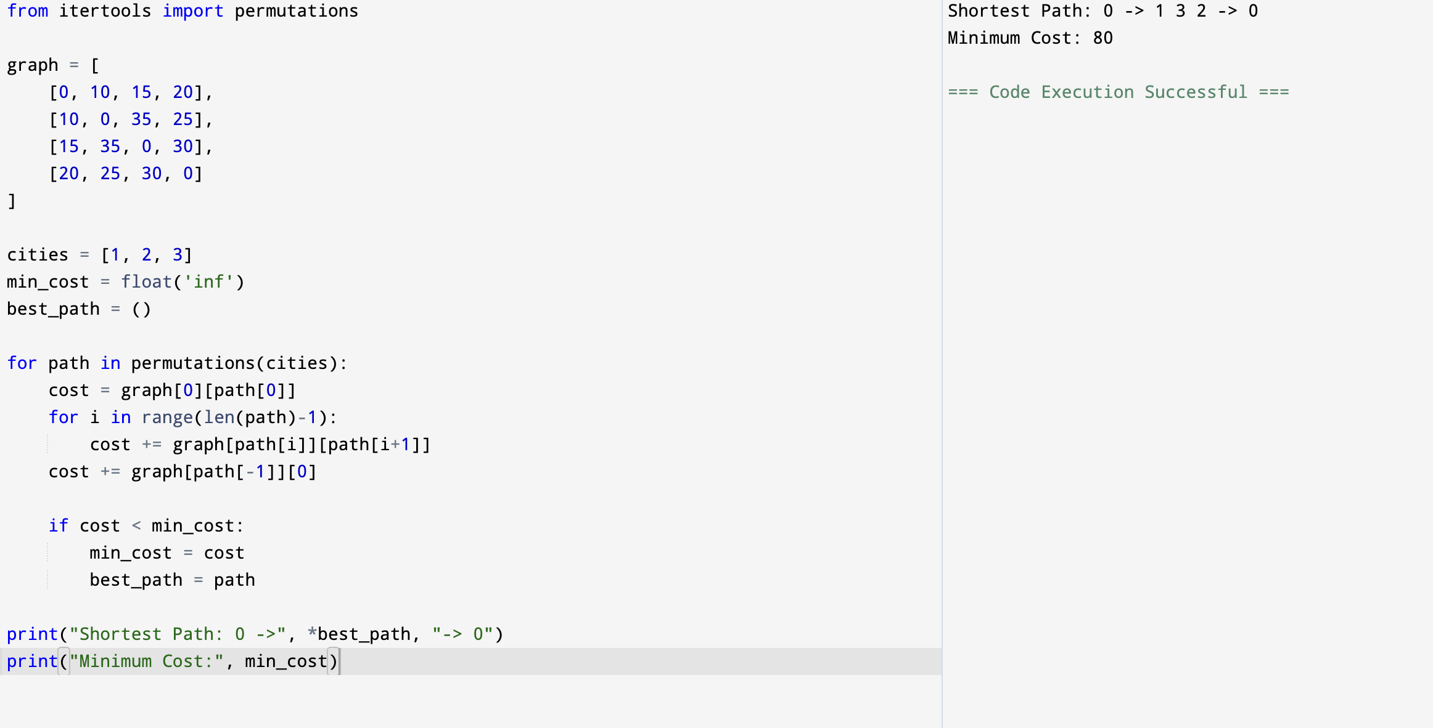
Output:

Result: Hence, Travelling Salesman problem has solved

